LAB NO 4:

TASKS

1: Write a program that takes two arrays of size 4 and swap the elements of those arrays.

CODE:

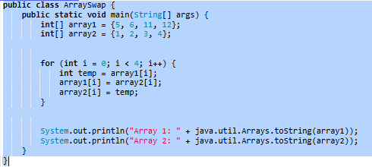

OUTPUT:



2: Add a method in the class that takes array and merge it with the existing one.

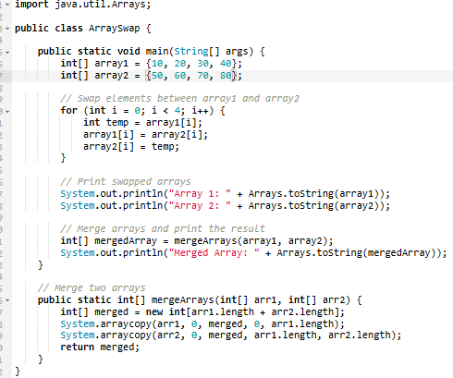

OUTPUT:

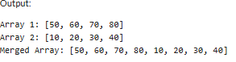

3: In a JAVA program, take an array of type string and then check whether the strings are palindrome or not.

CODE:

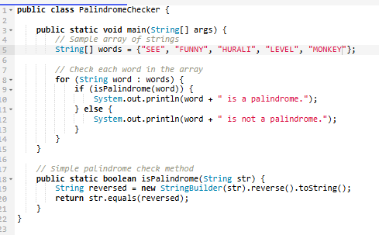

OUTPUT:

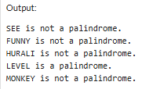

4: Given an array of integers, count how many numbers are even and how many are odd

CODE:

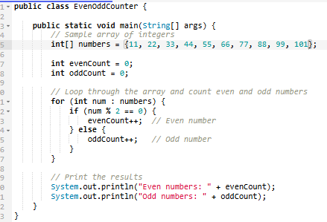

OUTPUT:

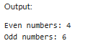

5: Given two integer arrays, merge them and remove any duplicate values from the resulting array.

CODE:

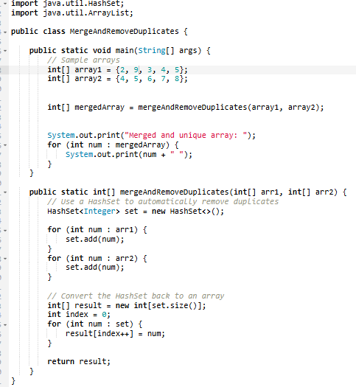

OUTPUT:



HOME TASKS:

1: Write a program that takes an array of Real numbers having size 7 and calculate the sum and mean of all the elements. Also depict the memory management of this task.

CODE;

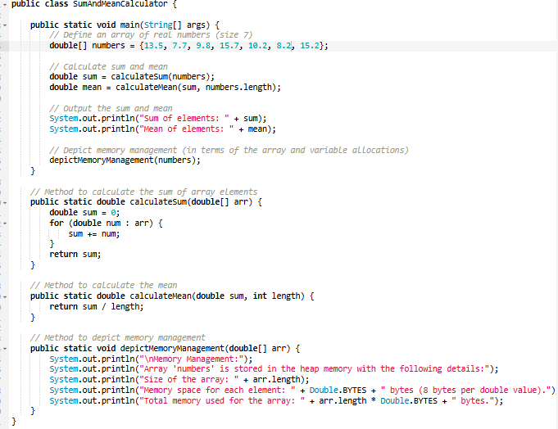

OUTPUT:

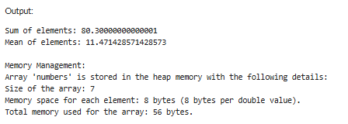

2; Add a method in the same class that splits the existing array into two. The method should search a key in array and if found splits the array from that index of the key.

C0DE:

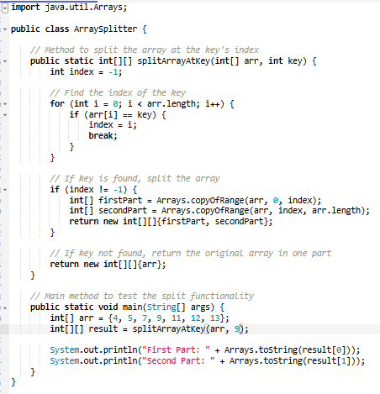

OUTPUT:

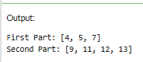

3: Given an array of distinct integers and a target integer, return all unique combinations of numbers that add up to the target. Each number can be used only once in the combination

CODE:

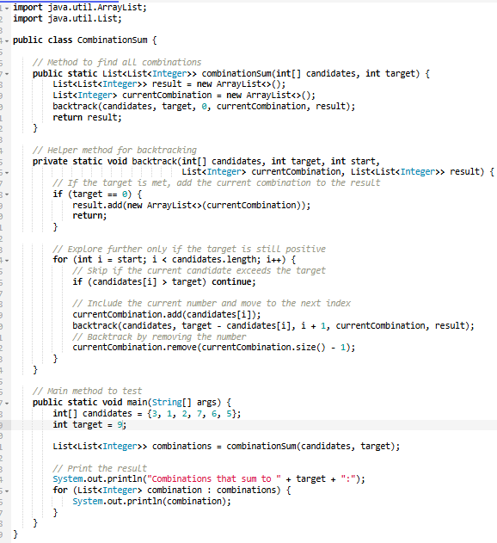

OUTPUT:

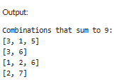

4: You are given an array containing n distinct numbers taken from 0, 1, 2, ..., n. Write a program to find the one number that is missing from the array.

CODE:

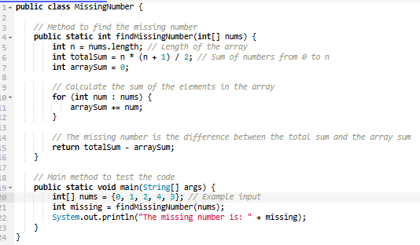

OUTPUT:

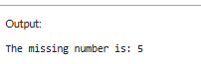

5: You are given an array of integers. Write a program to sort the array such that it follows a zigzag pattern: the first element is less than the second, the second is greater than the third,and so on.

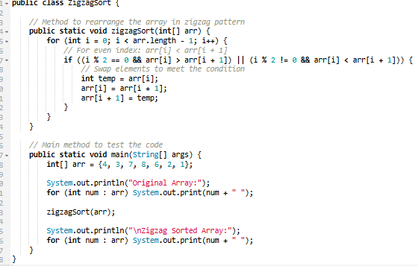

OUTPUT:

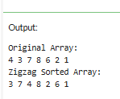

COMPLETED